How do archaeologists write about race? Computational text analysis of 40 years of Society of American Archaeology Annual Meeting Abstracts.

Myfirstname Mylastname1,✉, and Yourfirstname Yourlastname2

09 August, 2021

Text of abstract

1 University of One Place  
2 University of Another Place

✉ Correspondence: [Myfirstname Mylastname <[fl@oneplace.edu](mailto:fl@oneplace.edu)>](mailto:fl@oneplace.edu)

Keywords: keyword 1; keyword 2; keyword 3

Highlights: These are the highlights

knitr::include_graphics(here::here("analysis/figures/001-keyword-time-series.jpg"))

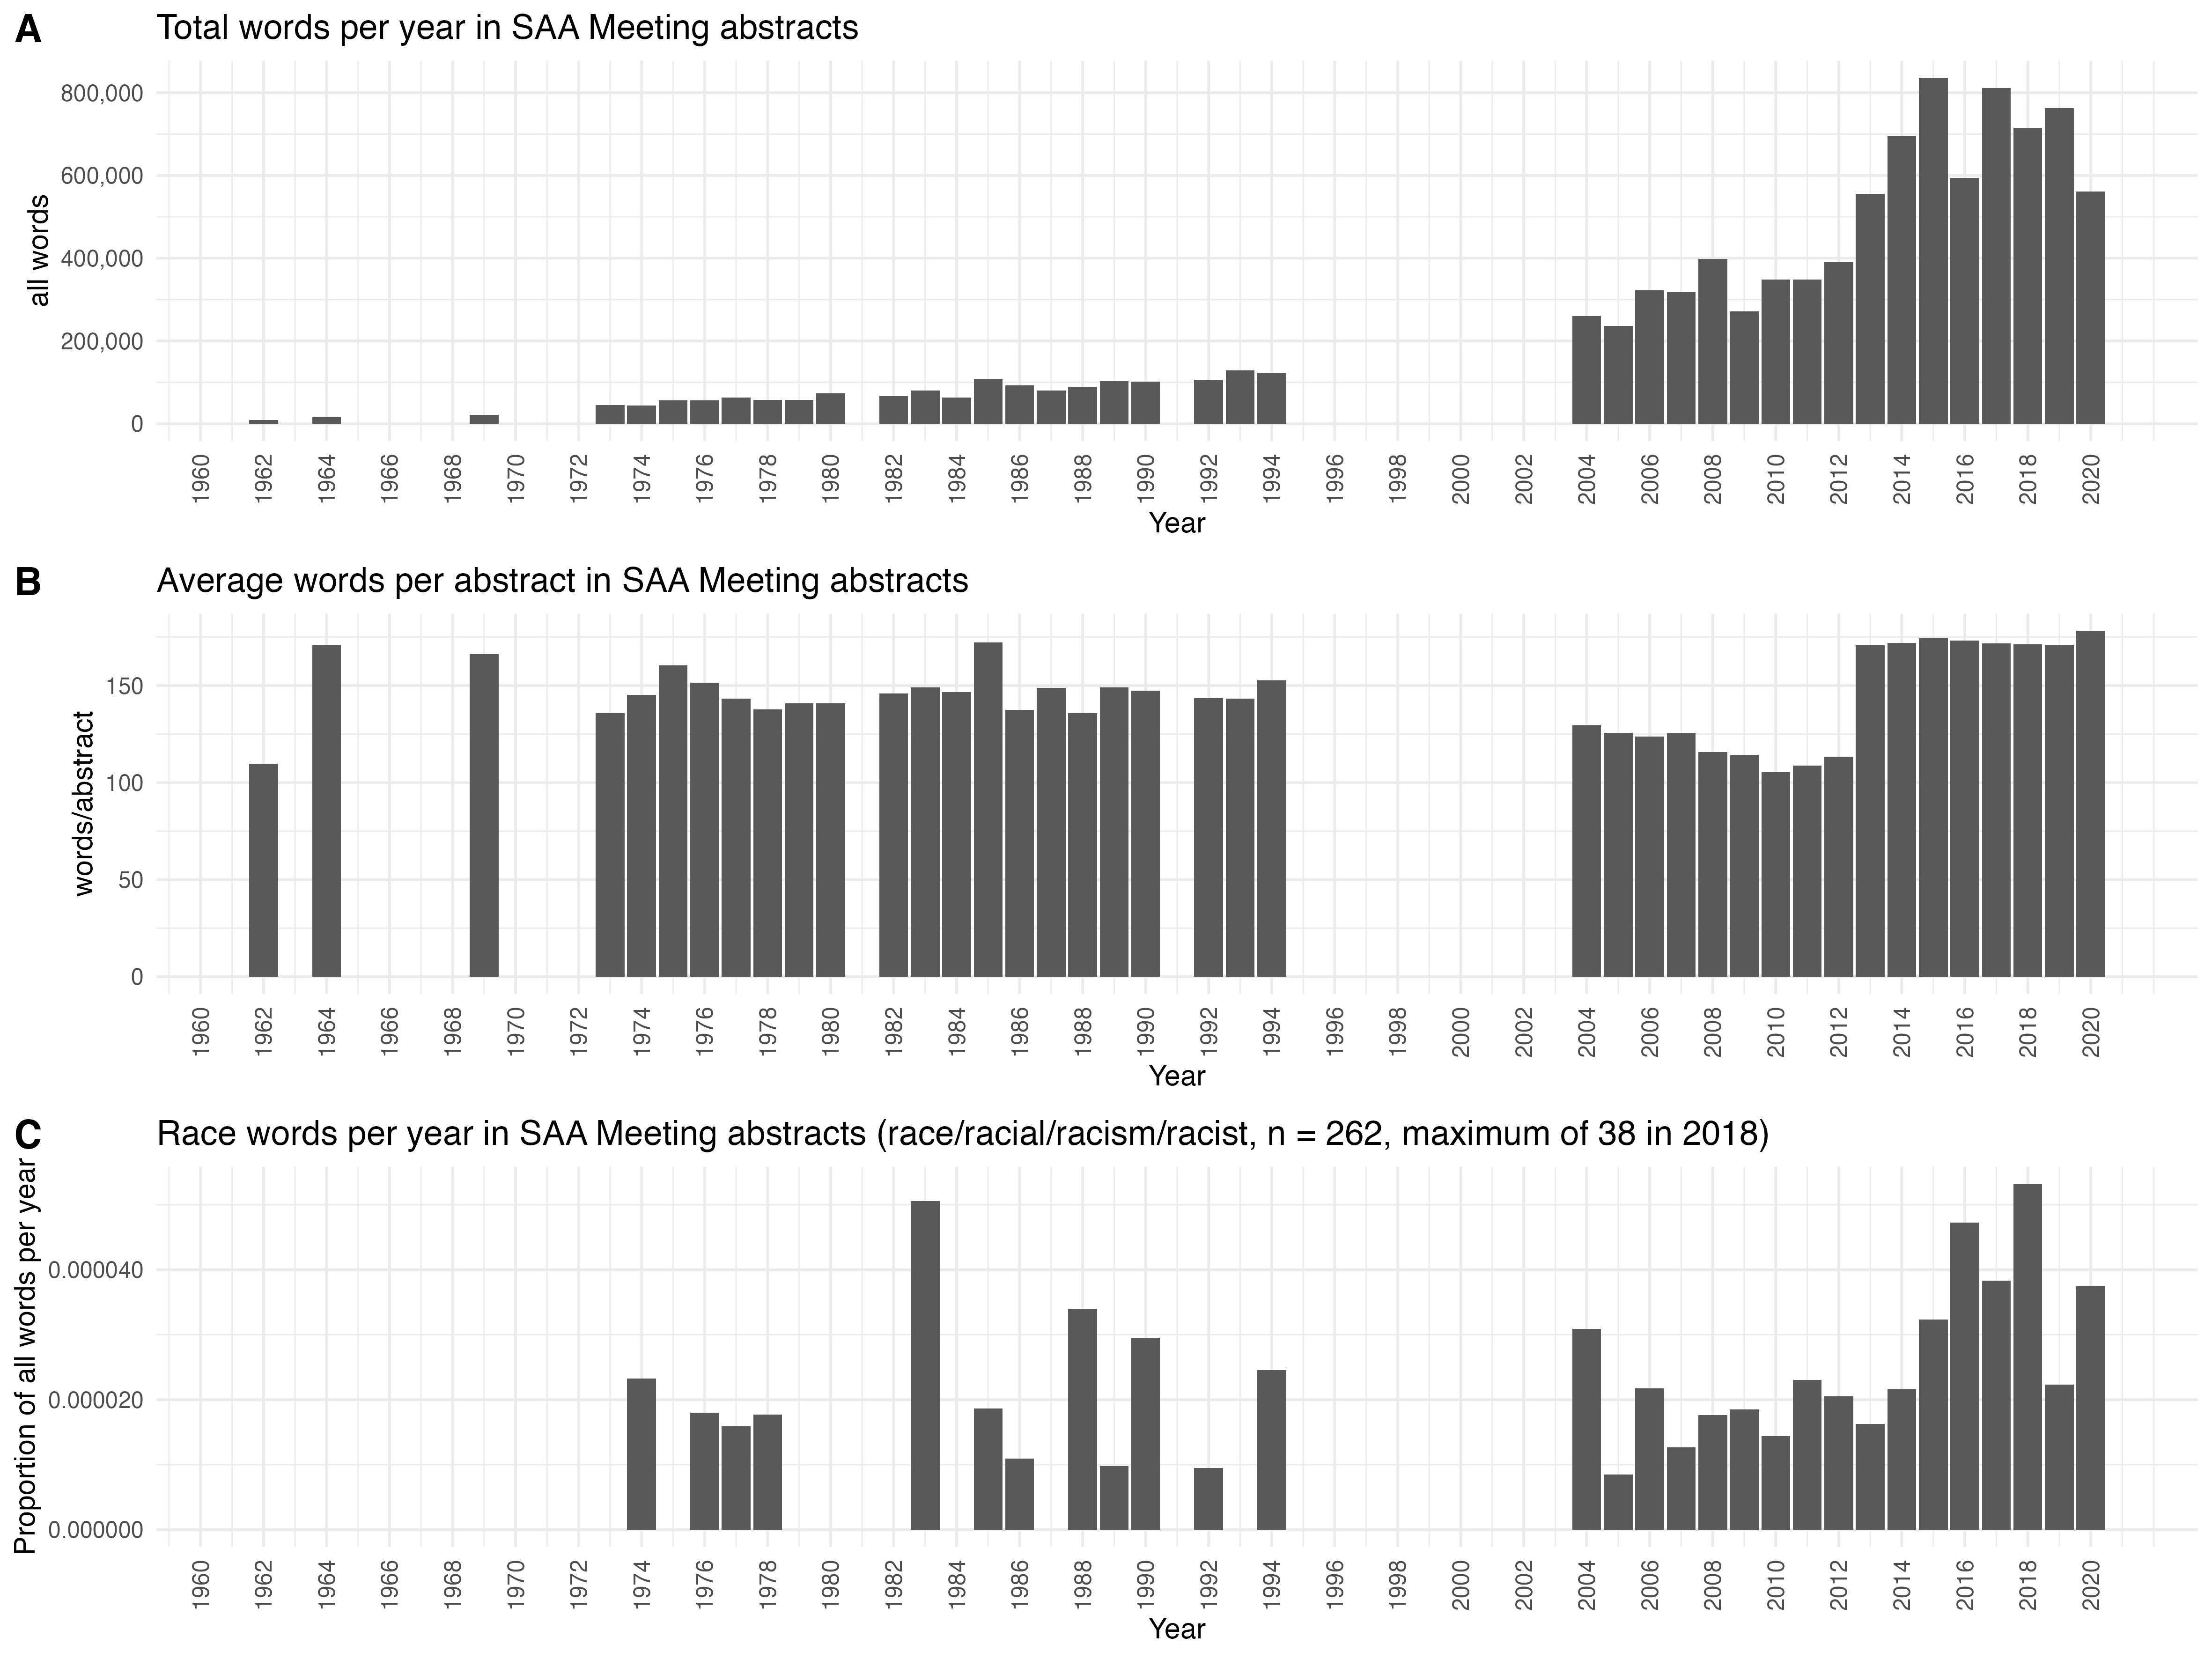

knitr::include_graphics(here::here("analysis/figures/002-topic-model.jpg"))



knitr::include_graphics(here::here("analysis/figures/003-keyword-similar-words.jpg"))

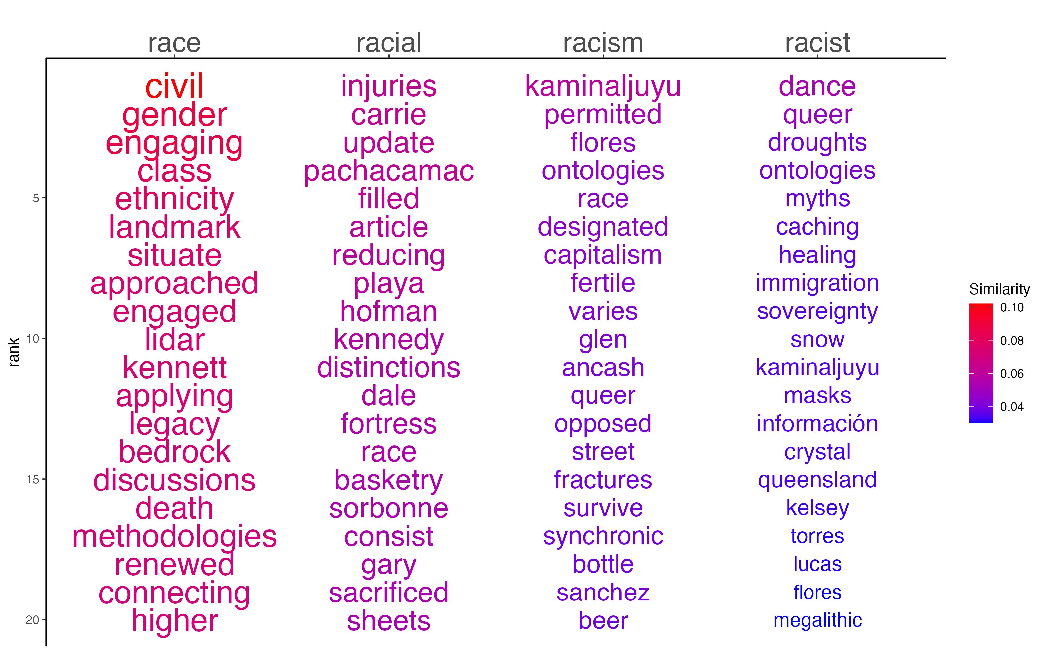

knitr::include_graphics(here::here("analysis/figures/004-keyword-kwic.jpg"))

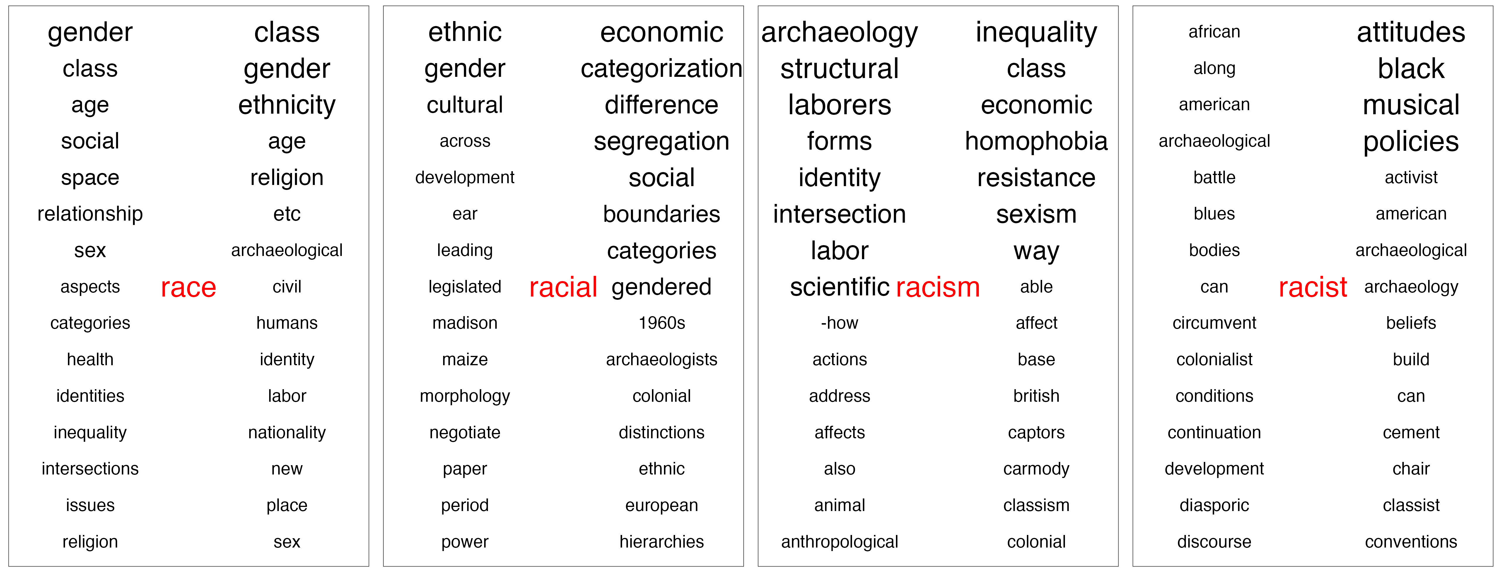

knitr::include_graphics(here::here("analysis/figures/005-keyword-and-event-relationships.jpg"))

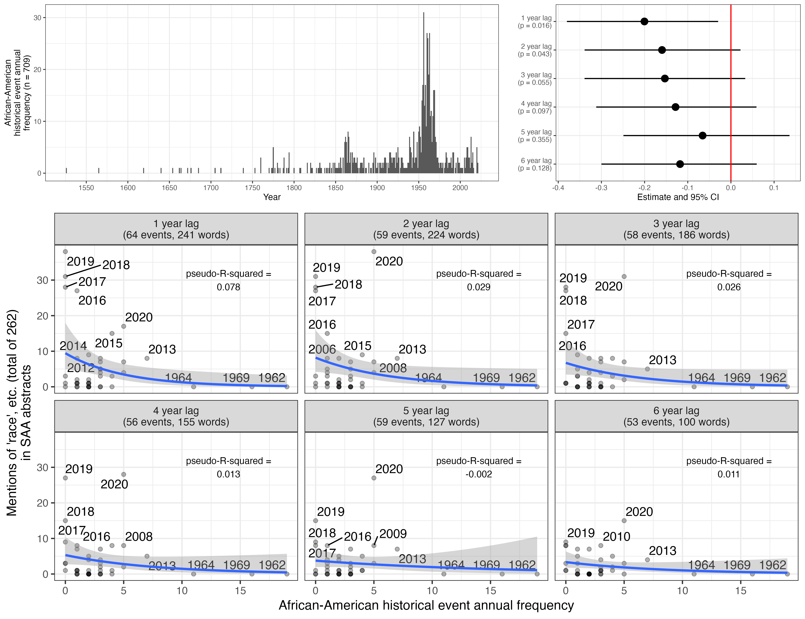

knitr::include_graphics(here::here("analysis/figures/006-ha-saa-boxplot.jpg"))

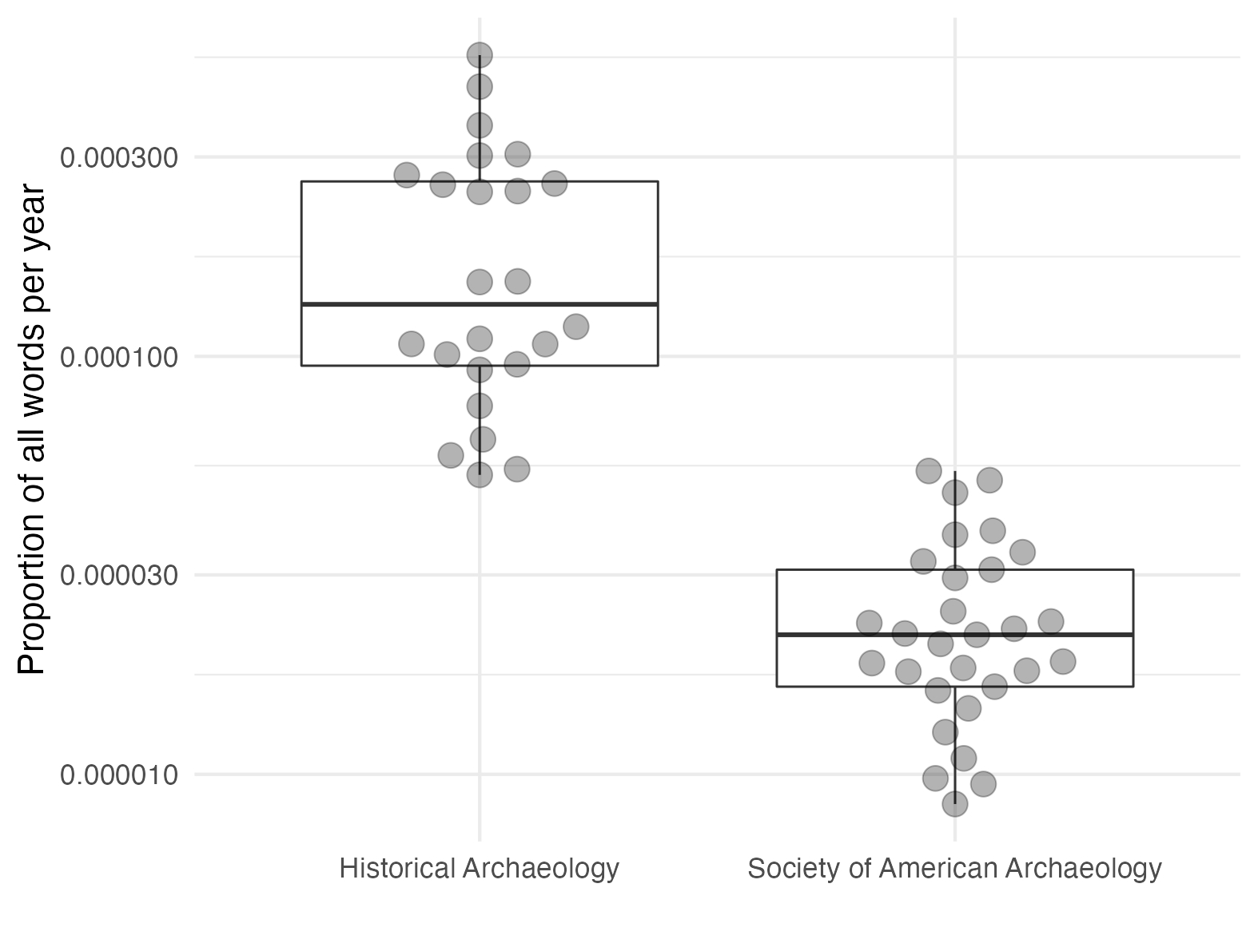

### 0.0.1 Colophon

This report was generated on 2021-08-09 15:18:22 using the following computational environment and dependencies:

# which R packages and versions?  
if ("devtools" %in% installed.packages()) devtools::session_info()  
#> ─ Session info ───────────────────────────────────────────────────────────────  
#> setting value   
#> version R version 4.0.5 (2021-03-31)  
#> os macOS Catalina 10.15.7   
#> system x86_64, darwin17.0   
#> ui X11   
#> language (EN)   
#> collate en_US.UTF-8   
#> ctype en_US.UTF-8   
#> tz America/Los_Angeles   
#> date 2021-08-09   
#>   
#> ─ Packages ───────────────────────────────────────────────────────────────────  
#> ! package * version date lib source   
#> P assertthat 0.2.1 2019-03-21 [?] CRAN (R 4.0.0)  
#> P backports 1.2.1 2020-12-09 [?] CRAN (R 4.0.2)  
#> P bookdown 0.22 2021-04-22 [?] CRAN (R 4.0.2)  
#> P broom 0.7.6 2021-04-05 [?] CRAN (R 4.0.2)  
#> P cachem 1.0.5 2021-05-15 [?] CRAN (R 4.0.2)  
#> P callr 3.7.0 2021-04-20 [?] CRAN (R 4.0.2)  
#> P cellranger 1.1.0 2016-07-27 [?] CRAN (R 4.0.0)  
#> P cli 2.5.0 2021-04-26 [?] CRAN (R 4.0.2)  
#> P codetools 0.2-18 2020-11-04 [?] CRAN (R 4.0.5)  
#> P colorspace 2.0-1 2021-05-04 [?] CRAN (R 4.0.2)  
#> P crayon 1.4.1 2021-02-08 [?] CRAN (R 4.0.2)  
#> P data.table 1.14.0 2021-02-21 [?] CRAN (R 4.0.2)  
#> P DBI 1.1.1 2021-01-15 [?] CRAN (R 4.0.2)  
#> P dbplyr 2.1.1 2021-04-06 [?] CRAN (R 4.0.2)  
#> P desc 1.3.0 2021-03-05 [?] CRAN (R 4.0.2)  
#> P devtools 2.4.1 2021-05-05 [?] CRAN (R 4.0.4)  
#> P digest 0.6.27 2020-10-24 [?] CRAN (R 4.0.2)  
#> P dplyr * 1.0.6 2021-05-05 [?] CRAN (R 4.0.4)  
#> P ellipsis 0.3.2 2021-04-29 [?] CRAN (R 4.0.2)  
#> P evaluate 0.14 2019-05-28 [?] CRAN (R 4.0.0)  
#> P fansi 0.5.0 2021-05-25 [?] CRAN (R 4.0.2)  
#> P fastmap 1.1.0 2021-01-25 [?] CRAN (R 4.0.2)  
#> P fastmatch 1.1-0 2017-01-28 [?] CRAN (R 4.0.0)  
#> P forcats * 0.5.1 2021-01-27 [?] CRAN (R 4.0.2)  
#> P fs 1.5.0 2020-07-31 [?] CRAN (R 4.0.2)  
#> P generics 0.1.0 2020-10-31 [?] CRAN (R 4.0.2)  
#> P ggplot2 * 3.3.3 2020-12-30 [?] CRAN (R 4.0.2)  
#> P glue 1.4.2 2020-08-27 [?] CRAN (R 4.0.2)  
#> P gtable 0.3.0 2019-03-25 [?] CRAN (R 4.0.0)  
#> P haven 2.4.1 2021-04-23 [?] CRAN (R 4.0.2)  
#> P here 1.0.1 2020-12-13 [?] CRAN (R 4.0.2)  
#> P highr 0.9 2021-04-16 [?] CRAN (R 4.0.2)  
#> P hms 1.1.0 2021-05-17 [?] CRAN (R 4.0.2)  
#> P htmltools 0.5.1.1 2021-01-22 [?] CRAN (R 4.0.2)  
#> P httr 1.4.2 2020-07-20 [?] CRAN (R 4.0.2)  
#> P igraph 1.2.6 2020-10-06 [?] CRAN (R 4.0.2)  
#> P jpeg 0.1-8.1 2019-10-24 [?] CRAN (R 4.0.2)  
#> P jsonlite 1.7.2 2020-12-09 [?] CRAN (R 4.0.2)  
#> P knitr 1.33 2021-04-24 [?] CRAN (R 4.0.2)  
#> P lattice 0.20-44 2021-05-02 [?] CRAN (R 4.0.2)  
#> P lifecycle 1.0.0 2021-02-15 [?] CRAN (R 4.0.2)  
#> P lubridate 1.7.10 2021-02-26 [?] CRAN (R 4.0.2)  
#> P magrittr 2.0.1 2020-11-17 [?] CRAN (R 4.0.2)  
#> P Matrix 1.3-3 2021-05-04 [?] CRAN (R 4.0.2)  
#> P memoise 2.0.0 2021-01-26 [?] CRAN (R 4.0.2)  
#> P modelr 0.1.8 2020-05-19 [?] CRAN (R 4.0.0)  
#> P munsell 0.5.0 2018-06-12 [?] CRAN (R 4.0.0)  
#> P pillar 1.6.1 2021-05-16 [?] CRAN (R 4.0.2)  
#> P pkgbuild 1.2.0 2020-12-15 [?] CRAN (R 4.0.2)  
#> P pkgconfig 2.0.3 2019-09-22 [?] CRAN (R 4.0.0)  
#> P pkgload 1.2.1 2021-04-06 [?] CRAN (R 4.0.2)  
#> P prettyunits 1.1.1 2020-01-24 [?] CRAN (R 4.0.0)  
#> P processx 3.5.2 2021-04-30 [?] CRAN (R 4.0.2)  
#> P ps 1.6.0 2021-02-28 [?] CRAN (R 4.0.2)  
#> P purrr * 0.3.4 2020-04-17 [?] CRAN (R 4.0.0)  
#> P quanteda * 3.0.0 2021-04-06 [?] CRAN (R 4.0.2)  
#> P R6 2.5.0 2020-10-28 [?] CRAN (R 4.0.2)  
#> P Rcpp 1.0.6 2021-01-15 [?] CRAN (R 4.0.2)  
#> P RcppParallel 5.1.4 2021-05-04 [?] CRAN (R 4.0.2)  
#> P readr * 1.4.0 2020-10-05 [?] CRAN (R 4.0.2)  
#> P readxl 1.3.1 2019-03-13 [?] CRAN (R 4.0.0)  
#> P remotes 2.3.0 2021-04-01 [?] CRAN (R 4.0.2)  
#> renv 0.13.2 2021-03-30 [1] CRAN (R 4.0.2)  
#> P reprex 2.0.0 2021-04-02 [?] CRAN (R 4.0.2)  
#> P rlang 0.4.11 2021-04-30 [?] CRAN (R 4.0.2)  
#> P rmarkdown 2.8 2021-05-07 [?] CRAN (R 4.0.4)  
#> P rprojroot 2.0.2 2020-11-15 [?] CRAN (R 4.0.2)  
#> P rstudioapi 0.13 2020-11-12 [?] CRAN (R 4.0.2)  
#> P rvest 1.0.0 2021-03-09 [?] CRAN (R 4.0.2)  
#> P scales 1.1.1 2020-05-11 [?] CRAN (R 4.0.0)  
#> P sessioninfo 1.1.1 2018-11-05 [?] CRAN (R 4.0.0)  
#> P stopwords 2.2 2021-02-10 [?] CRAN (R 4.0.2)  
#> P stringi 1.6.2 2021-05-17 [?] CRAN (R 4.0.2)  
#> P stringr * 1.4.0 2019-02-10 [?] CRAN (R 4.0.0)  
#> P tarchetypes * 0.2.0 2021-05-11 [?] CRAN (R 4.0.2)  
#> P targets * 0.4.2 2021-04-30 [?] CRAN (R 4.0.2)  
#> P testthat 3.0.2 2021-02-14 [?] CRAN (R 4.0.2)  
#> P tibble * 3.1.2 2021-05-16 [?] CRAN (R 4.0.2)  
#> P tidyr * 1.1.3 2021-03-03 [?] CRAN (R 4.0.2)  
#> P tidyselect 1.1.1 2021-04-30 [?] CRAN (R 4.0.2)  
#> P tidyverse * 1.3.1 2021-04-15 [?] CRAN (R 4.0.2)  
#> P usethis 2.0.1 2021-02-10 [?] CRAN (R 4.0.2)  
#> P utf8 1.2.1 2021-03-12 [?] CRAN (R 4.0.2)  
#> P vctrs 0.3.8 2021-04-29 [?] CRAN (R 4.0.2)  
#> P withr 2.4.2 2021-04-18 [?] CRAN (R 4.0.2)  
#> P xfun 0.23 2021-05-15 [?] CRAN (R 4.0.2)  
#> P xml2 1.3.2 2020-04-23 [?] CRAN (R 4.0.0)  
#> P yaml 2.2.1 2020-02-01 [?] CRAN (R 4.0.0)  
#>   
#> [1] /Users/bmarwick/Desktop/bulletinracisminarchy/renv/library/R-4.0/x86_64-apple-darwin17.0  
#> [2] /private/var/folders/mz/6nn330m17_37ck5hhz2p24100000gn/T/RtmpeyjaqT/renv-system-library  
#> [3] /private/var/folders/mz/6nn330m17_37ck5hhz2p24100000gn/T/Rtmpg1A9tJ/renv-system-library  
#>   
#> P ── Loaded and on-disk path mismatch.

The current Git commit details are:

# what commit is this file at?   
if ("git2r" %in% installed.packages() & git2r::in_repository(path = ".")) git2r::repository(here::here())   
#> Local: master /Users/bmarwick/Desktop/bulletinracisminarchy  
#> Remote: master @ origin (https://github.com/parkgayoung/bulletinracisminarchy)  
#> Head: [fd9d48c] 2021-08-09: finalise figures for Supplement